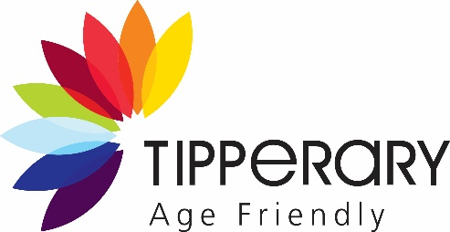
National Positive Ageing Week
Friday the 25th September to 2nd October 2026
Small grant scheme for older adult community groups
Positive Ageing Week theme for 2026 is ‘Connecting Generations’ - Older and younger generations often live in separate worlds. A coffee morning bridges that gap with warmth and friendship.
https://positiveageingweek.com/
Tipperary County Council and Tipperary Age Friendly offer a small grant scheme to support Older Adult Community Groups in County Tipperary to support social interactions and connectivity and the theme for the national positive ageing week.
The grant will support Older adult community groups to host an event 25th September to 2nd October 2026.
A proposed maximum grant of €250 is available
The Grant Scheme intention is to support older adult groups in reconnecting and reengaging and celebrating the contribution of older people to County Tipperary
- Last date for receipt of applications 12 noon Tuesday 8th September 2026
- Applications will only be accepted from community groups whose focus is on engaging older adults and facilitating and older adult group for e.g. Senior Citizens Group, Active Retirement, Men’s Sheds etc.
- Applicants will be notified by close of business on the 10th September 2026 if they are successful.
- All community groups must be registered with Tipperary PPN - https://www.ppntipperary.ie/
- Within the application the Community group must identify their event date.
- All of the events will be collated and promoted on www.tipperarycoco.ie and on the Tipperary Age Friendly Calendar through https://www.whatsonintipp.ie/ to showcase all of the community groups supported to engage Positive Ageing Week.
- This grant will not fund an event that is already receiving other funding, or recurring events.
- There should be no charge where possible for participants to attend your event.
- The community group will pay any costs associated with their event directly.
- The event must be cultural in nature, promoting positive ageing, whether music, arts, drama, in nature, the group can define to suit their groups demands.
- Following the event all approved applicants submit their receipt to agefriendly@tipperarycoco.ie and the grant of €250 will be paid to the community group.

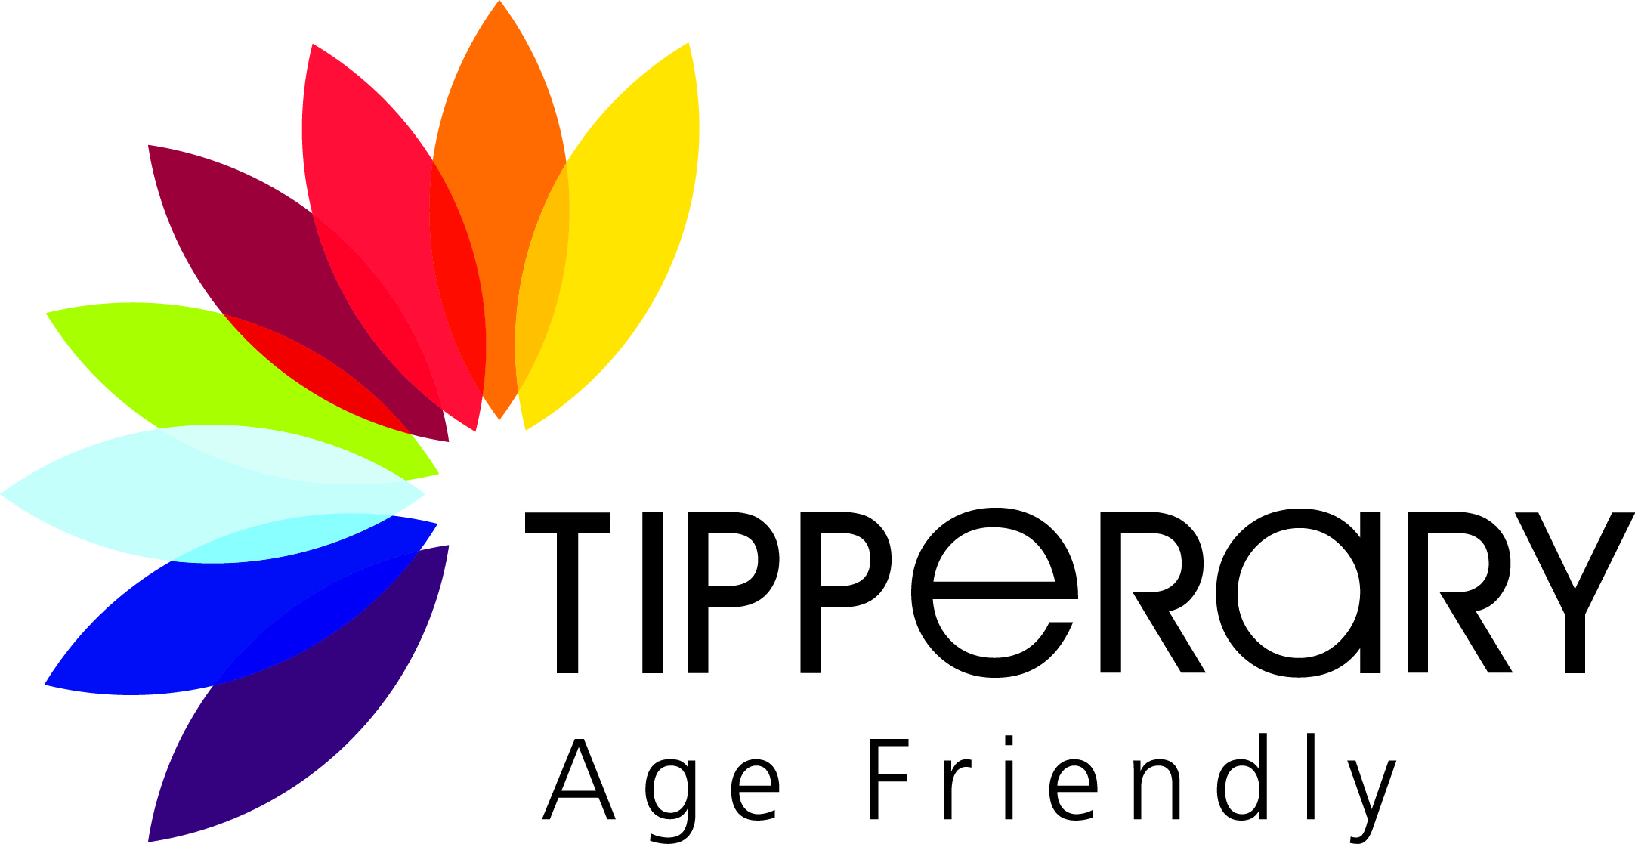

Positive Ageing Week 2026
‘Connecting Generations’
Community Group Activity Grant Application

Name of Community Group
Contact for Application Name
Contact Number
Contact email address
Tipperary PPN number

Where will event take place
Event
Date of Proposed Activity
(25th September to 2nd October)

Time of Proposed Activity
Note this activity will be promoted on www.tipperarycoco.ie and on https://www.whatsonintipp.ie/ as part of Tipperary Older Adults Festival
Are new members welcome to attend your event
Signed on behalf of the Community group
Date

