IRELAND’S CAP STRATEGIC PLAN 2023 – 2027
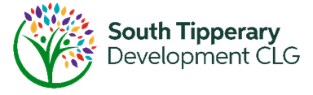
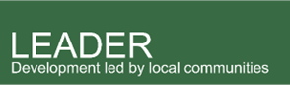
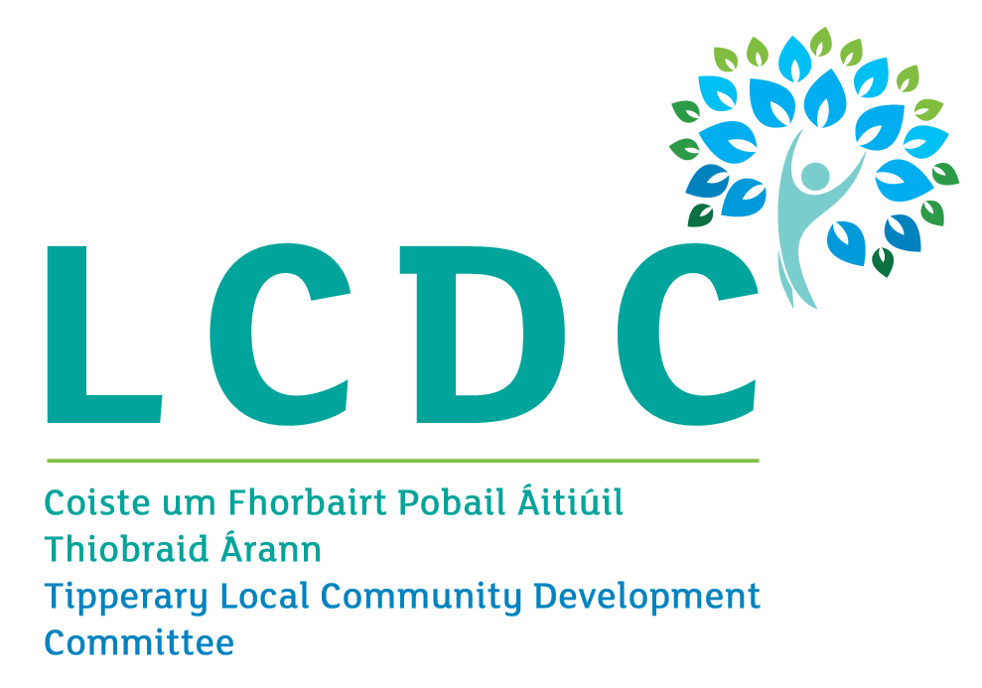

Targeted Call for Projects 2026
Rural Youth (age 15-40)

Overview
Funding is available through the LEADER Programme for community organisations, youth-focused groups, enterprises and social enterprises to carry out projects that contribute to improving opportunities, participation, wellbeing, skills development, employment prospects, and social inclusion for young people.
Eligible projects will address one or more of the following:
- Supporting youth participation in community development, leadership, and decision-making.
- Developing skills, training, mentoring, and employment pathways for rural young people.
- Enhancing youth wellbeing, diversity, inclusion and access to services.
- Improving recreational, cultural, creative, educational, and social opportunities for young people.
- Developing innovative projects that help retain and attract young people to live, work, and engage in rural communities.
- Supporting youth entrepreneurship, digital skills, and enterprise development.

Total Budget Available: €115,629
Minimum grant per project: €10,000 Maximum grant per project €50,000

Types of Projects
Potential projects which could be funded under this call may include one or more of the following:
- Development or enhancement of dedicated youth spaces, hubs, recreation facilities and meeting places.
- Youth leadership, participation and volunteering programmes.
- Skills development, mentoring and employability initiatives for young people.
- Youth entrepreneurship and innovation projects.
- Programmes supporting youth wellbeing, social inclusion and community engagement.
- Arts, culture, creative and heritage projects led by or involving young people.
- Digital skills, technology and media projects for rural youth.
- Initiatives that encourage young people to remain in, return to or contribute to rural communities.

Examples may include:
- Equipment and fit-out for a youth hub, club or youth café.
- A youth leadership and mentoring programme.
- Enterprise and entrepreneurship workshops for young people.
- A digital media, podcasting or creative technology project.
- A youth wellbeing and resilience programme.
- Development of a youth volunteering network.
- Community arts, music or cultural projects designed and delivered by young people.

However, this list is not exhaustive, and we welcome all project ideas that contribute to improving opportunities and quality of life for young people in South Tipperary.

Rates of Grant Aid available:
Type of Project | Grant aid
Capital Projects eg equipment, works etc | Up to 75%, Maximum €50,000
Analysis and Development / Audits / Feasibility Studies. | Up to 90%, Maximum €30,000
Training Projects | Up to 100%, Maximum €50,000

Who can apply?
- Community and voluntary organisations.
- Youth groups and youth organisations.
- Social enterprises.
- Community-owned enterprises.
- Partnerships involving youth organisations and local stakeholders.
- Enterprises where the primary benefit is the development of opportunities for rural young people.

What is not eligible?
- Mainstream education provision, including activities that are the responsibility of schools, colleges, Education and Training Boards (ETBs) or higher education institutions.
- Childcare facilities and childcare service provision.
- Routine youth service operating costs, including salaries, utilities, rent and overheads.
- Mainstream sporting activities of mainstream sporting organisations.

Application Process
You should first complete a short Expression of Interest (EOI) form outlining your project idea. The form is available on the South Tipperary Development CLG (STDC) website at https://stdc.ie/rural-development-programme-leader/. This must be submitted by 18/09/2026
Development Officers in South Tipperary Development Clg (STDC) are available to advise and assist in the process.
An Expression of Interest requires brief information about:
- Your organisation.
- The proposed project.
- Estimated project costs.
- How the non-grant-aided portion of the project will be financed.

If your EOI is deemed eligible, you will be invited to submit a full application by 01/12/2026 (indicative date).
Depending on the nature of the project, applicants may be required to provide:
- Organisational information.
- Financial statements or accounts.
- Tax clearance documentation.
- Business or project plans.
- Planning permissions or exemptions where applicable.
- Quotations and procurement documentation in line with public procurement guidelines.
- Evidence of need and community benefit.

No work can commence until formal approval is granted and a contract is signed. Any work that takes place before that cannot be grant aided. We anticipate contracts to be issued to successful projects in Q1 2027.

This is a competitive call for projects across South Tipperary. Completed project applications will be evaluated by an independent evaluation committee, and the final decision on funding will be made by the Tipperary Local Community Development Committee.

Further information
Please contact one of the project development officers for an informal discussion, prior to submitting your EOI. Detailed information about the LEADER programme is available on the STDC website below.
South Tipperary Development CLG on 052-7442652 www.stdc.ie Email: rdp@stdc.ie;

